Brian Laccone

11/5/17

CS 290

Project Proposal

The website that I would like to create is called Arteik. This site will be a social art critiquing website where users can upload their artwork (photographs, paintings, drawing, etc..), critique other’s artwork, and receive critiques on their artwork. This website started as an idea that my cousin and I had while he was learning graphic design. Fortunately for me, he gave me all the concept mock ups for the website that we had talked over back when we thought about making this website. I will only be using the home page, image page, profile page, and search page for this assignment. I will not be able to implement all the features that are shown in the mock ups because they would require a database and PHP but I will do my best to include as much as I can.

(For the sake of formatting I will explain the 4 pages first and then show all the mock ups at the end)

**Home Page**

The landing page will consist of a simple page that includes the Arteik logo, pictures, and links to the other four pages. In the mock up, it shows a bunch of photos around the Arteik logo. I will be changing that section to be a slide show instead because the assignment rubric calls for a slide show on the home page. The pictures in the slide show will link to the image page for that picture. I will get rid of the 5 icons under the pictures because the user will not able to register, sign in, or upload in this version of the website. I may include a download button to download something on this page but I am not sure yet. The “News and Update” section will utilize a scroll box to satisfy the grading requirements.

**Image Page**

The image page will consist of the image that was linked in the url (through clicking on the picture from another page). This page will include the picture, title, description, artist who created it, and links to other pictures. You will be able to click on the artist’s picture to go to their profile page. The other pictures on the mock up will link to the image page of that picture. I am not sure if I will be including critiques or not on this page because they would most likely be the same critiques for every picture because I don’t have a database at the current moment.

**Search Page**

This page will be the hardest to create without a database because the search function will not be implemented without a database full of pictures to search through. I will, however, have all the pictures that will be on the website, visible in this section. I may be able to have the “sort by” selection button only show predetermined pictures for that category. Each picture will be clickable to redirect to their image page. The pictures will also display information when hovered over.

**Profile Page**

This page will include all the information on the artist. The artist’s work will be displayed as well as a description on the artist. The pictures will be split into portfolios and galleries. I will most likely only have one artist for the whole site for grading purposes. All pictures will be linked to their respective image pages.

**Home page**



**Image Page**

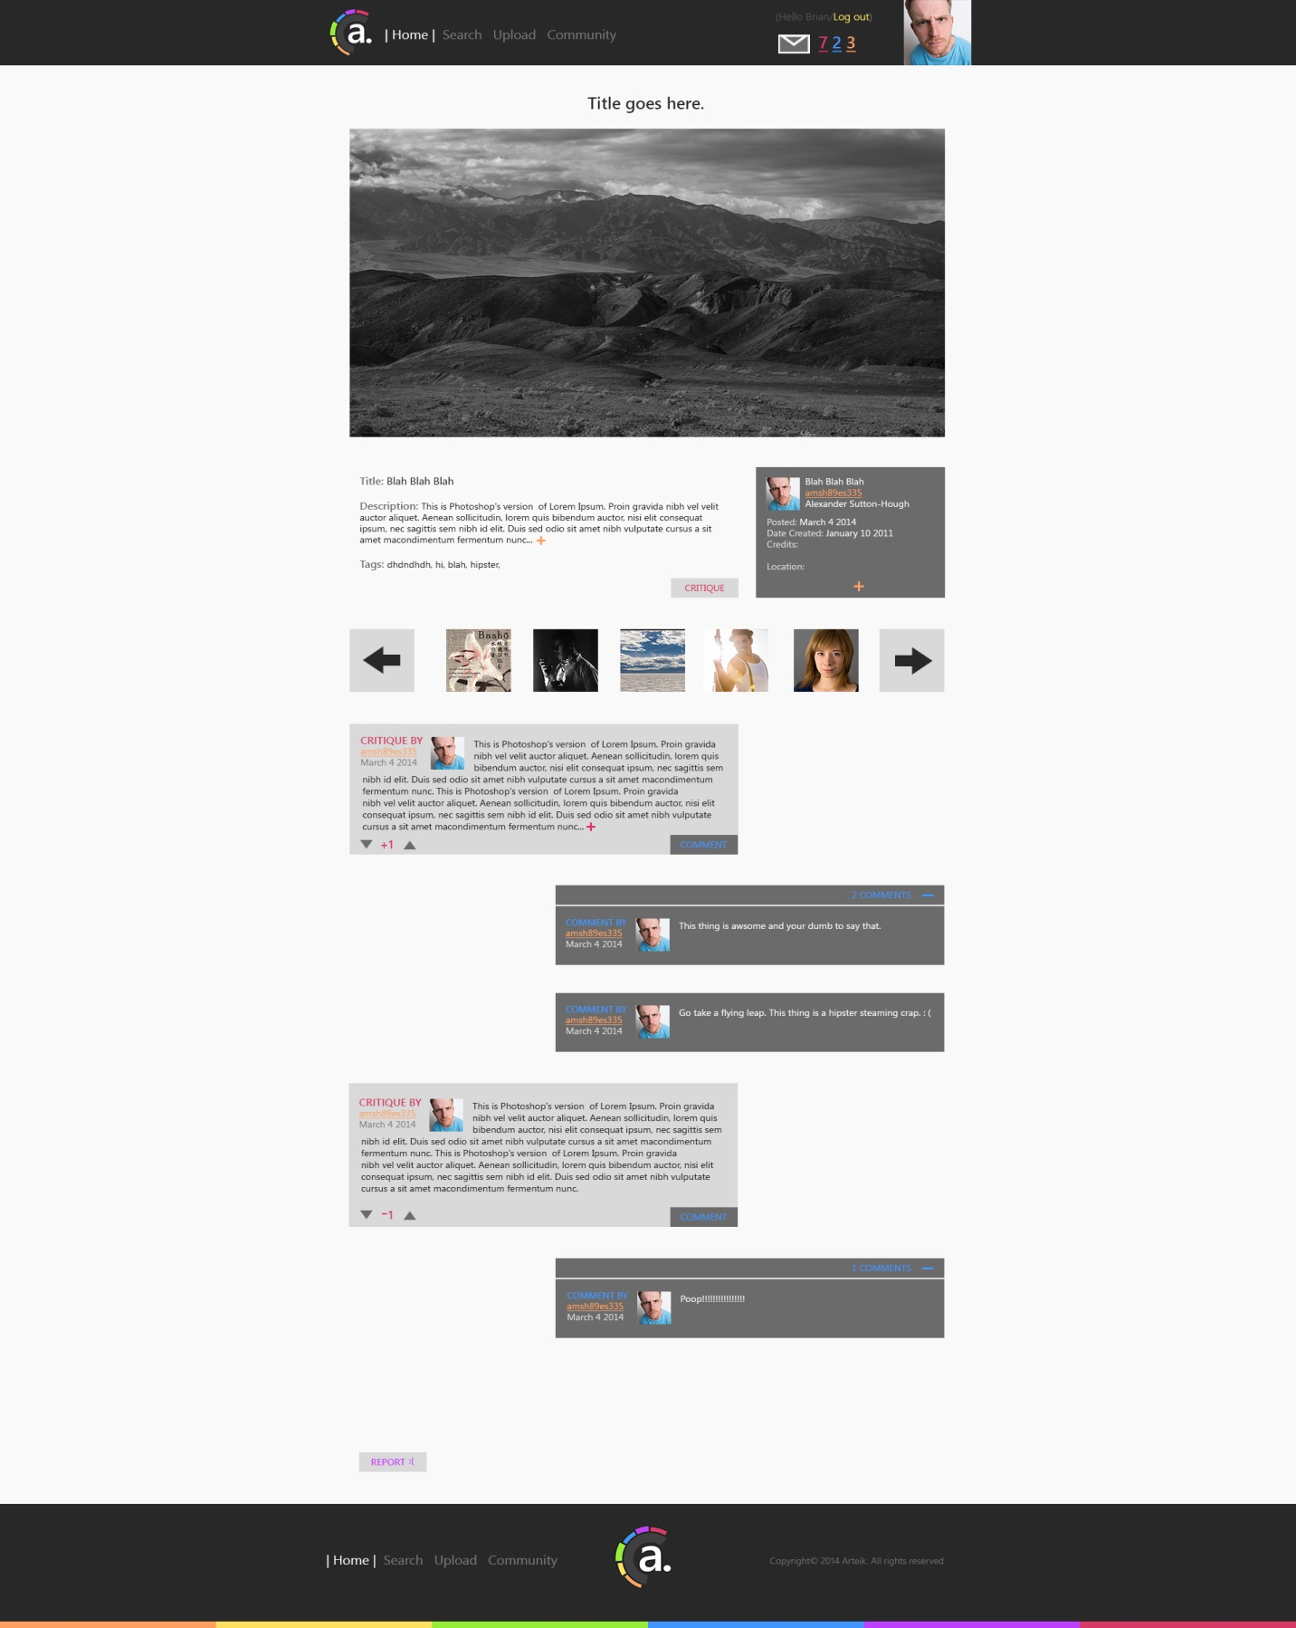

**Search Page**

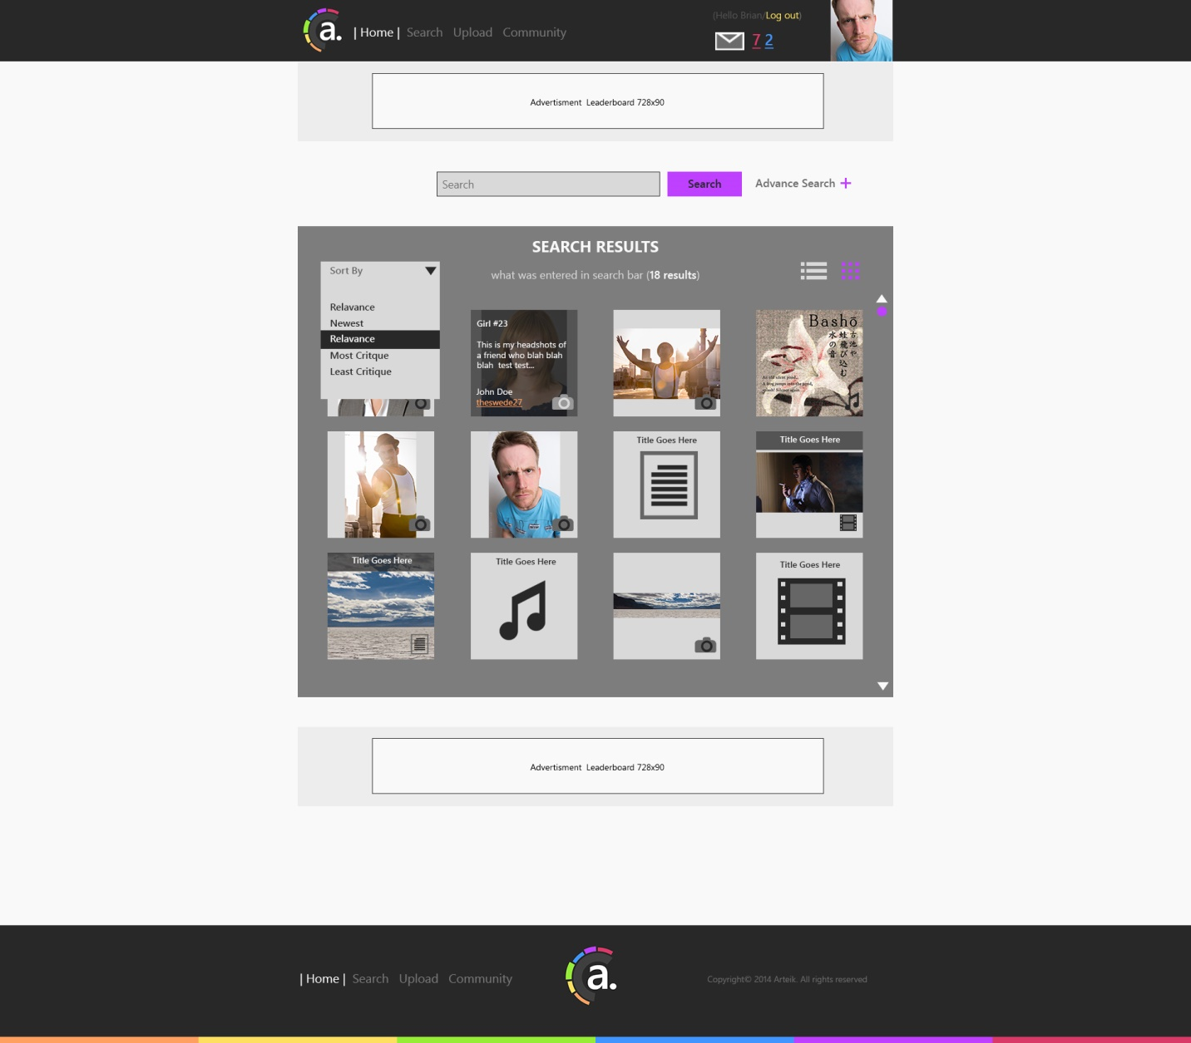

**Profile Page**

